

**IBM Product Master**

**Proof of Concept**

Version: 1.0

**Table of Contents**

1. Revision History 3

2. Introduction 4

3. Manual VS Automation Time Difference 4

**3.1 Manual Steps:** 4

**3.2 Automation Steps:** 9

**3.3 Signoff Email.** 11

**3.4 Additional Features:** 11

# **1. Revision History**

|  |  |  |  |
| --- | --- | --- | --- |
| **Revision** | **Date(mm/dd/yy)** | **Author** | **Summary of Change** |
| 1.0 | 22/02/2023 | SivaPrasad Konduru | Initial Draft |
|  |  |  |  |
|  |  |  |  |
|  |  |  |  |
|  |  |  |  |

# **2. Introduction**

IBM Product Master (formerly IBM InfoSphere® Master Data Management Collaborative Edition) provides trusted product information management (PIM) and collaborative master data management (MDM) capabilities. It creates an accurate and up-to-date repository of product and service information that can be used throughout organizations to help achieve strategic business initiatives. IBM Product Master aggregates information from any upstream system, enforces business processes to ensure data accuracy and consistency, and synchronizes trusted information with downstream systems.

IBM Product Master helps organizations achieve better operational efficiency, manage compliance and drive data-based digital transformation.

# **3. Manual VS Automation Time Difference**

## **3.1 Manual Steps:**

If we do it manually, Deployment and Manual steps time taken for **> 20 Mins.**

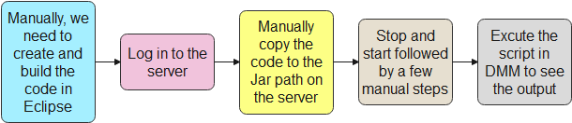

***Step by Step Process***

**Manually, we need to create and build the code in Eclipse:**

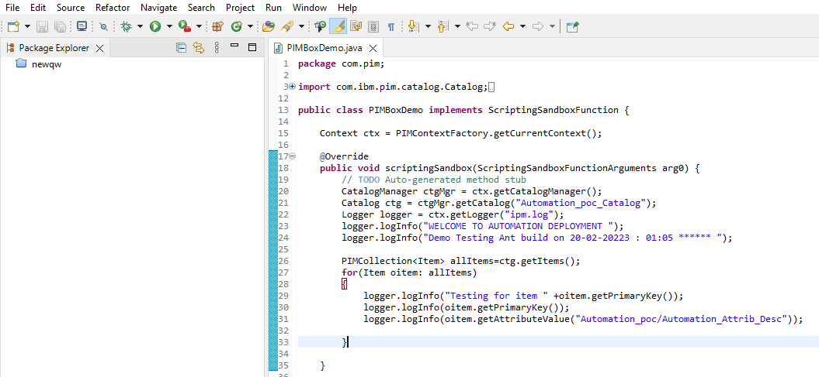

**Build Code**



**Log in to the server:**

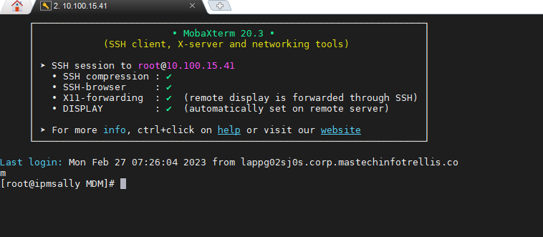

**Manually copy the code to the Jar path on the server:**

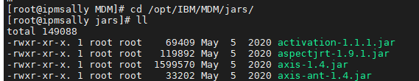 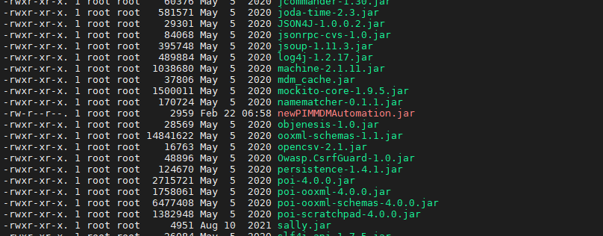

**Stop and Start followed by a few manual steps process:**

[root@ipmsally MDM]# cd bin/go

**[root@ipmsally go]# ./stop_local.sh**

Stopping service workflowengine_IPMSALLY...

Stopping service eventprocessor_IPMSALLY...

Stopping service queuemanager_IPMSALLY...

Stopping service appsvr_IPMSALLY...

Stopping service scheduler_IPMSALLY...

Stopping service admin_IPMSALLY...

Stopping service rmi_IPMSALLY...

STOPPING DASHBOARDS SERVICE

===========================

Derby is not running..

--------------------------------------

***## This step we need to provide Yes or No option ##***

[root@ipmsally go]# cd ..

***[root@ipmsally bin]# ./configureEnv.sh***

Validating config file '/opt/IBM/MDM/bin/conf/env_settings.ini'...OK

Checking service definitions..OK

Configured for db type: db2

Configured for app server type: websphere

INFO: Copying /opt/IBM/MDM/etc/default/websphere/ccd_sso.jar to /opt/IBM/MDM/jars/

Determining classpath..

Jar file /opt/IBM/WebSphere/AppServer/java/jre/lib/xml.jar not found - did you rebuild anttasks?

done

Determining preload classpath..done

Generating flow-config.xml file

There are no changes in the /opt/IBM/MDM/etc/default/flow-config.default.xml and /opt/IBM/MDM/etc/default/flow-config.xml files.

Generating common.properties file(s)

Configuring for ent_install mode

app server 'appsvr_IPMSALLY', port=7507

etc dir=/opt/IBM/MDM/etc/default

location=/opt/IBM/MDM/etc/default/common.properties

Updating existing file

/opt/IBM/MDM/etc/default/common.properties exists. Overwrite? (y/n) **n**

INFO: GDS component is disabled, skipping GDS specific configuration.

Generating configuration files for logging

log dir: /opt/IBM/MDM/logs

Generating log.xml

/opt/IBM/MDM/etc/default/log.xml exists. Overwrite? (y/n) **n**

Generating log_cbe.xml

/opt/IBM/MDM/etc/default/log_cbe.xml exists. Overwrite? (y/n) **n**

Generating log_cbe_pattern.xml

/opt/IBM/MDM/etc/default/log_cbe_pattern.xml exists. Overwrite? (y/n) **n**

Configuring env

Checking suppliers directory: creating

Generating properties file for data entry

/opt/IBM/MDM/etc/default/data_entry_properties.xml exists. Overwrite? (y/n) **n**

Generating properties files for spell service

/opt/IBM/MDM/etc/default/plugins/wintertree/spellservice.properties exists. Overwrite? (y/n) n

Generating config files for cache system

/opt/IBM/MDM/etc/default/mdm-ehcache-config.xml exists. Overwrite? (y/n) **n**

Check Java class

/opt/IBM/MDM/etc/default/db.xml exists. Overwrite? (y/n) **n**

Generating /opt/IBM/MDM/bin/compat.sh

Updating existing file

/opt/IBM/MDM/etc/default/mass-edit/config/mass-edit.properties exists. Overwrite? (y/n) **n**

Properties in the file /opt/IBM/MDM/etc/default/mass-edit/config/mass-edit.properties are not updated. Please update the file manually.

Updating existing file

/opt/IBM/MDM/mdmui/dynamic/mdmrest/restConfig.properties exists. Overwrite? (y/n) **n**

Properties in the file /opt/IBM/MDM/mdmui/dynamic/mdmrest/restConfig.properties are not updated. Please update the file manually.

Updating existing file

/opt/IBM/MDM/mdmui/dynamic/mdmui/config.json exists. Overwrite? (y/n) **n**

Properties in the file /opt/IBM/MDM/mdmui/dynamic/mdmui/config.json are not updated. Please update the file manually.

Generating config files for cache system

/opt/IBM/MDM/mdmui/dynamic/mdmrest/mdm-rest-cache-config.xml exists. Overwrite? (y/n) **n**

IPM configuration completed

-------------------------------

***[root@ipmsally bin]# chmod 777 compat.sh***

***[root@ipmsally bin]# ./compat.sh***

***[root@ipmsally bin]# ./updateRtClasspath.sh***

Jar file /opt/IBM/WebSphere/AppServer/java/jre/lib/xml.jar not found - did you rebuild anttasks?

[root@ipmsally bin]# cd go/

***[root@ipmsally go]# ./start_local_rmlogs.sh***

Removing contents of logs directory

Running service pre-start checks

Starting service rmi_IPMSALLY... started, PID is 18604

Starting service eventprocessor_IPMSALLY... started, PID is 18618

Starting service workflowengine_IPMSALLY... started, PID is 18641

Starting service admin_IPMSALLY... started, PID is 18671

Starting service appsvr_IPMSALLY... Class path for MDMPIM app server 'ipmserver' has changed since last start. Updating...

started, PID is 19224

Starting service queuemanager_IPMSALLY... started, PID is 19571

Starting service scheduler_IPMSALLY... started, PID is 19587

**Execute the script in DMM to see the output**:

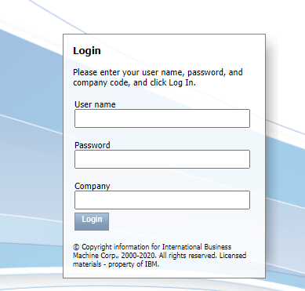

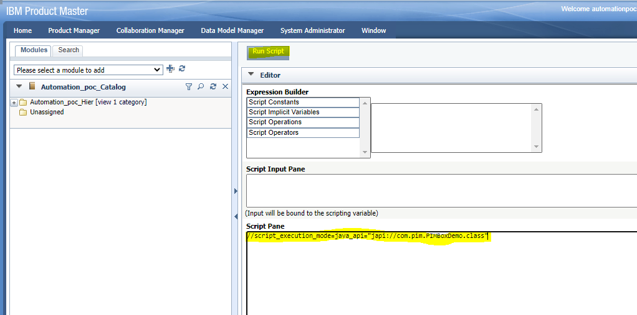

**IPM Expected Output:**

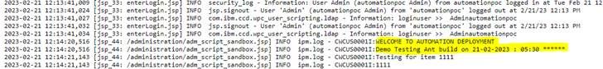

## **3.2 Automation Steps:**

If we use the CICD pipeline, Deployment and manual steps time taken **< 3 Mins.**

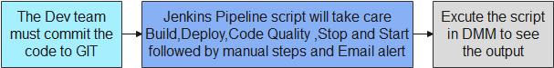

***Commit the code into GitHub***



***Jenkins Pipeline will Take care the below steps:***

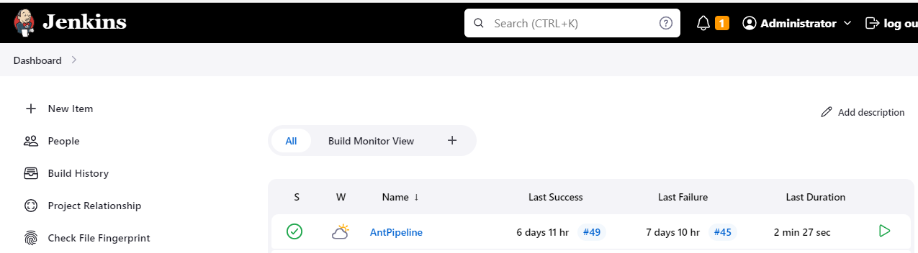

**Pipeline Stages**

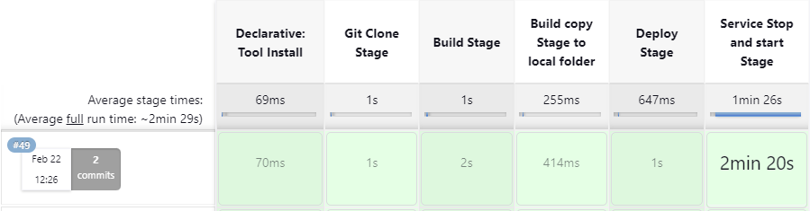



**Execute the script in DMM to see the output**:





**IPM Expected Output:**



## **3.3 Signoff Email.**

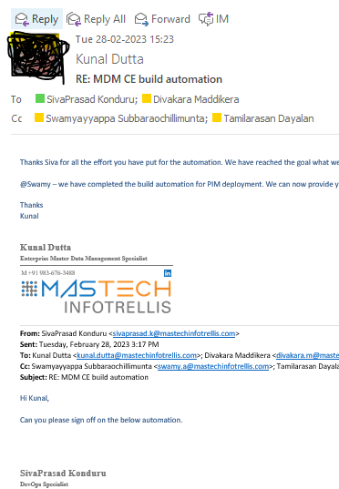

## **3.4 Additional Features:**

We can add QA and Production deployment in same pipeline with the approving option for the next environments.

Once Deployment completed in the Dev environment, it will wait for approval for the QA deployment.

We can add Slack and Email notification.

**For Ex:**

